“QUANTUM CRYPTOGRAPHY”
SIMULATION OF BB84 PROTOCOL
A Project Report
Submitted in fulfilment of the requirements for
the sessional subject “Project (EC7210)” for the completion of Degree in Bachelor of Engineering


Submitted By
RAJ KUMAR (BE/1245/2011)
ASHUTOSH KUMAR (BE/1212/2011)
ARNAVESH VARUN GIRI (BE/1388/2011)

Under the Guidance of:
DR. R. SUKESH KUMAR

DEPARTMENT OF ELECTRONICS AND COMMUNICATION ENGINEERING
BIRLA INSTITUTE OF TECHNOLOGY
MESRA – 835215, RANCHI
SP-2015

DECLARATION CERTIFICATE

This is to certify that the work presented in the thesis entitled “Quantum Cryptography: Simulation of BB84 Protocol” in fulfilment of the requirement for the sessional subject “PROJECT (EE7210)” in Electronics and Communication Engineering of Birla Institute of Technology, Mesra, Ranchi is carried out under my supervision and guidance.

To the best of my knowledge, the content of this report does not form a basis for the award of any previous degree to anyone else.

DR. R. SUKESH KUMAR
Professor & Dean (Faculty Affairs)
Project Guide
Department of Electronics and Communication Engineering
Birla Institute of Technology, Mesra

Certificate of Approval

This is to certify that the project entitled “Quantum Cryptography : Simulation of BB84 Protocol” is hereby approved as a suitable design of an engineering subject carried out and presented in satisfactory manner to warrant its acceptance as pre-requisite to the degree for which it has been submitted.
It is understood that by this approval, the undersigned do not necessarily endorse any conclusion drawn or opinion expressed therein, but approve the project for which it is submitted.

Internal Examiner External Examiner
Date: Date:

Dr. V. R. Gupta
Head of Department
Department of Electronics and Communication Engineering

ACKNOWLEDGEMENT

We owe our deepest gratitude to our guide Dr. R.Sukesh Kumar, who helped us throughout the project, despite his extremely busy schedule. He made sure that we learnt by practice, always motivating us to think a step further, work a little harder. Our interactions with him always resulted in newer ideas and proved beneficial towards our work. Without his constant presence and supervision our work would not have been successful.

We especially would like to extend our gratitude to our esteemed professors Mr. Priyank Saxena and Mr. Rupesh Kumar Sinha for their inspiration and support throughout our project.

We are very grateful to Dr. V.R.Gupta, Prof & Head, Dept. Of Electronics and Communication Engineering, Birla Institute of Technology Mesra for extending all the facilities and giving valuable suggestions at all times for pursing this course.

And lastly our batchmates who have always been there with valuable suggestions and support in our endeavours.

Raj Kumar Ashutosh Kumar
Arnavesh Varun Giri

TABLE OF CONTENTS

- Introduction 6-10
- Quantum key distribution 10-12
- BB84 Protocol 13-16
- BB84 Protocol Implementation 17
- Flowchart 18
- Proposed Algorithm 19-23
- C Implementation And Screenshots 24-28
- Conclusions 29
- References 30

INTRODUCTION

The development of quantum cryptography was inspired by the short comings of classical cryptography methods, which can be classified as “public-key systems”, “private-key systems”, and “One-time pad systems”.

In classical cryptography communicating parties need to share a secret sequence of random numbers, the key, that is exchanged by physical means and thus open to security loopholes. The current encryption protocols based on mathematical algorithms introduce security holes related to the key refresh and key expansion ratio. Keys can be easily compromised in many ways by brute-force deciphering, by espionage from within the company or by hacking using Trojan or sniffer software to gather key information.

Data transmission has always been vulnerable to eavesdropping. Conventional cryptography has provided security in data communication however it has some limitations when dealing with passive eavesdropping. Recently, the quantum mechanics has made a remarkable entry in the field of data communication. The purpose of quantum key distribution (QKD) and classical key distribution are same, the only difference lies in their realization methods.

The classical cryptography, such as RSA, Diffie-Hellman, and AES, does not detect eavesdropping, but protects data instead based on the computational difficulty of solving an underlying problem.In other words, an eavesdropper can get the encrypted data, but cannot do anything with it.

However, classical schemes for key distribution rely on the unproven computational assumptions, and if someone discovers a fast technique for

factoring large integers, the RSA cryptosystem will not survive anymore. Also the higher amount of computation in the process of encryption and decryption significantly reduces the channel capacity bits per second of message information. As computing power increases, and new classical computational techniques are developed, the length of time that a message can be considered secure will decrease, and numerical keys will no longer be able to provide acceptable levels of secure communications.

To summarize that, modern cryptography is vulnerable to both technological progress of computing power and evolution in mathematics to quickly reverse one way functions such as that of factoring large integers. For that reason, for past decade efforts have been made to establish new foundation for cryptography science in the computer communications networks. One of these efforts has led to the development of quantum cryptography technology, whose security relies on the laws of quantum mechanics.

Advances in quantum physics have stimulated interest in its potential impact on such technology.

Quantum cryptography utilizes states of individual quantum systems for the transfer of conventional classical bits of information. The impossibility of measuring quantum systems without disturbing them guarantees the detection of eavesdropping and hence secure information transfer is possible.

Basics of Quantum Cryptography

Before we begin, it is worth explaining that a unit of quantum information is named after the quantum analog of the classical bit: a qubit (quantum bit). Like bits, qubits can have two possible values (0 or 1), although they can also be a superposition of both. Prior to measurement, a quantum object can exist in a superposition state; however, the measurement itself may damage this state. Following that, the object’s state will be determined by measurement.

In 1927 Werner Heisenberg published one of the fundamental principles of quantum mechanics. He proved that it is not possible to assign exact simultaneous values to the position and momentum of a physical system, and these quantities can only be determined with some characteristic uncertainty. In general, the Heisenberg uncertainty principle states that it is impossible to measure certain physical quantities with the same high precision. Position and momentum are only one example of such pairs. Another example could be polarizations of photons.

Let us consider an experiment with polarized photons and a birefringent calcite crystal. Birefringence is the decomposition of a ray of light into two rays (the ordinary ray and the extraordinary ray) when it passes through materials such as calcite crystals. This decomposition depends on the polarization of the light. We can assume that horizontally polarized photons appear in the upper ray, and vertically polarized photons appear in the bottom ray.

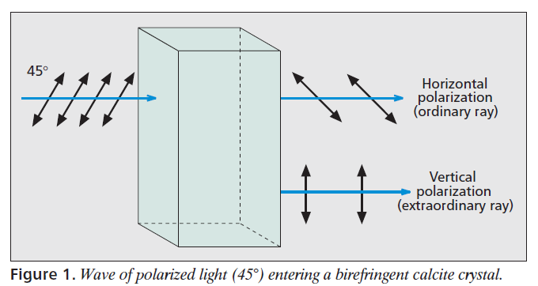

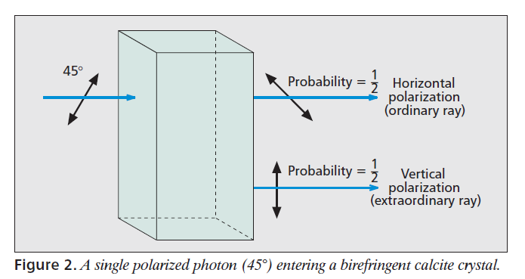
If we polarize the light at 45° and enter it in the input of the birefringent calcite crystal, we should obtain vertical and horizontal polarization components split at the output (ordinary and extraordinary rays). An example is presented in Fig. 1. However, if we transmit only one photon with the polarization 45°, it cannot be simultaneously vertical and horizontal at the output. It “chooses” only one of the polarizations with a probability of 1/2. The experiment with a single photon is presented in Fig. 2.

Using this calcite crystal we are only able to measure perfectly the photons with vertical and horizontal polarizations (0° and 90°), and we lose the information about diagonally polarized photons. Similarly, if we rotate the calcite crystal by 45°, we can measure perfectly only the photons with diagonal polarizations (45° and -45°). In this case we lose information about horizontally and vertically polarized photons.

Quantum Key Distribution

Quantum cryptography introduces an entirely new way of solving the key distribution/agreement problem. It is used to distribute an encryption key for symmetric ciphers, but not to transmit data messages between end users. It provides secure key distribution by applying the laws of quantum mechanics. These ensure that any measurement modifies the state of the transmitted qubit. This modification can be discovered by the sender and the receiver of qubits. Additionally, according to the no-cloning theorem, it is not possible to create identical copies eavesdropper is not able to clone the original qubit to measure the quantum state and simultaneously send the second qubit to the intended receiver. These rules make quantum cryptography a very secure solution.

To ensure such a high level of security, quantum cryptography requires two types of channels:
• A quantum channel, which is used to transmit qubits with the information about the distributed key
• A public channel, where end users check whether the communication through the quantum channel is distorted

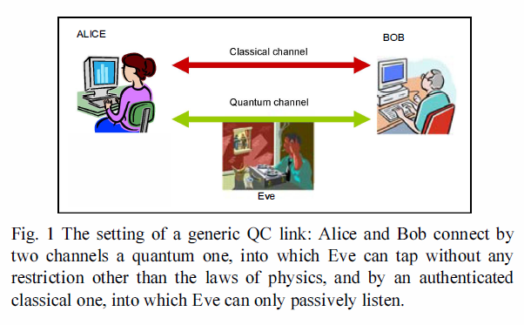

We identified two types of QKD protocols: those based on single particles and those based on entanglement. The first group transmits information about keys using the quantum state of single particles (i.e., polarized photons). The quantum states of each particle can be read independently because they do not depend on each other.

The second group is based on entangled particles. The entangled state of two particles has the following feature: prior to the measurement, the states of particles are completely random; however, if we measure the state of the first particle, the state of the second particle is fully determined. We need measure only one particle to know the quantum states of both.

There are many QKD protocols available today, but only a few are used in practice [2]. The first protocol to have been invented was BB84, proposed by Bennett and Brassard in 1984 [3].. It was developed by one of the BB84 creators, Bennett, in 1992. It is faster and more efficient than its predecessor. However, it requires very precisely calibrated detectors. A well-known QKD protocol using entangled particles is E91, invented by Ekert in 1991.

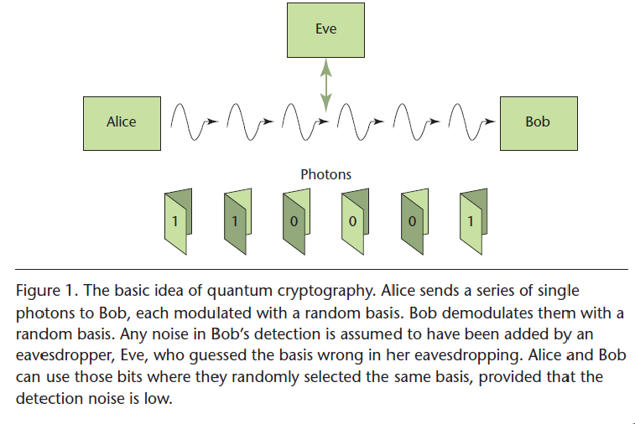

BB84 Protocol

Although we know of several QKD protocols, the most popular is still BB84. It is based on information encoded using the polarization of photons. Figure 3 presents an example of the key distribution process in the BB84 protocol.

In common with many papers related to cryptography, let us introduce three characters: Alice (usually the sender), Bob (usually the receiver), and Eve (the eavesdropper). In a typical scenario, Alice and Bob want to communicate secretly by establishing a cryptographic key. Eve wants to gain information about this key.

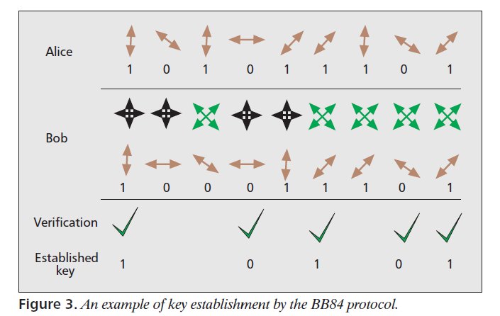

When Alice wants to establish a new key with Bob, they both have to define two alphabets: rectilinear and diagonal. We can assume that in the rectilinear alphabet photons with horizontal polarization 0° mean bit 0 and photons with vertical polarization 90° mean bit 1. Similarly, in the diagonal alphabet, photons with polarization –45° mean bit 0, and photons with polarization 45° mean bit 1. In Fig. 3 the double-headed arrows represent the polarization states of individual photons.

Bob is only able to perfectly measure photons with polarization 0° and 90° using a detector oriented in the vertical/horizontal directions (called the rectilinear basis). If he observes one photon with diagonal polarization (–45° or 45°) using the rectilinear basis, the photon “chooses” one of the polarizations — horizontal or vertical — with a probability of 1/2. The information about diagonally polarized photons is lost. Similarly, using the diagonal basis, the receiver is only able to perfectly measure photons with polarization –45° and 45°. In this situation, the information about horizontally and vertically polarized photons (0° and 90°) is lost. In Fig. 3, two crossed double-headed arrows, –45° and 45°, mean the diagonal basis (green arrows). Similarly, two crossed double-headed arrows, 0° and 90°, mean the rectilinear basis (black arrows).

At the start of the protocol operation, Alice sends Bob a string of bits, which is encoded using polarized photons (qubits). Alice sends the bits using a randomly chosen alphabet (rectilinear or diagonal) via a quantum channel. Bob receives this string using the rectilinear basis (enabling perfect detection of polarizations 0° and 90°) or the diagonal basis (enabling perfect detection of polarizations –45° and 45°). Bob chooses the basis randomly, but he informs Alice which basis he used. He sends this information via a public channel. It is worth emphasizing that Bob discloses only information about the basis he used, while the result of the measurement is kept secret. Now, Alice informs Bob when she has chosen the right basis to measure the photon’s polarization. The new key consists of those bits for which Bob has chosen the basis correctly. Only then do Alice and Bob have the same string of bits. In the example presented in Fig. 3, the first photon is detected perfectly and will be the first bit of the new key. Alice and Bob have to reject the second and third bits because Bob chose the wrong basis, and the measured polarization is uncertain. The next bit (fourth) is detected perfectly and will be part of the key. The algorithm ensures that the distributed key consists of approximately half the bits sent by Alice. The remaining bits must be rejected. Another Example of such key establishment is shown below.

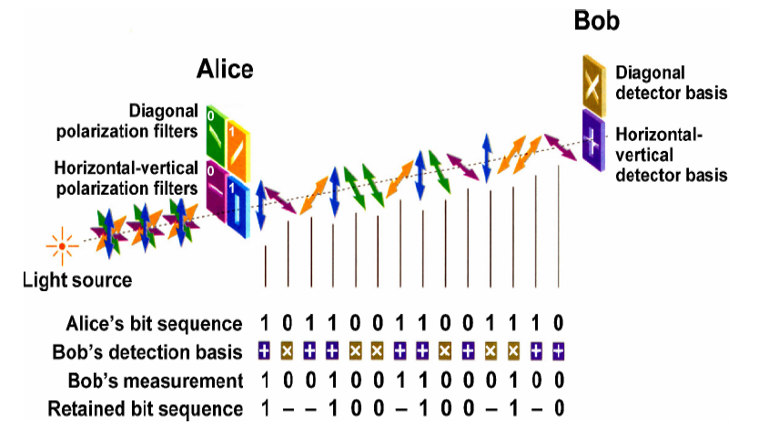

Now, let us assume that Eve eavesdrops in the quantum channel during the communication between Alice and Bob. To obtain information, Eve has to measure the polarization of photons using the rectilinear or diagonal basis. She chooses the basis randomly; however, if the chosen basis is incorrect, the polarization will be changed. Such an effect is presented in Fig. 4. Originally, the first bit has a vertical polarization (bit 1), but Eve eavesdrops using a diagonal basis, and after that the photon has 45° polarization. After Bob’s measurement, this photon has a horizontal polarization and will be decoded as bit 0. Even though Alice sent a vertically polarized photon and Bob selected the correct rectilinear basis, they obtained different bits. Therefore, if Alice and Bob compare the part of the key, they uncover the eavesdropping Eve.

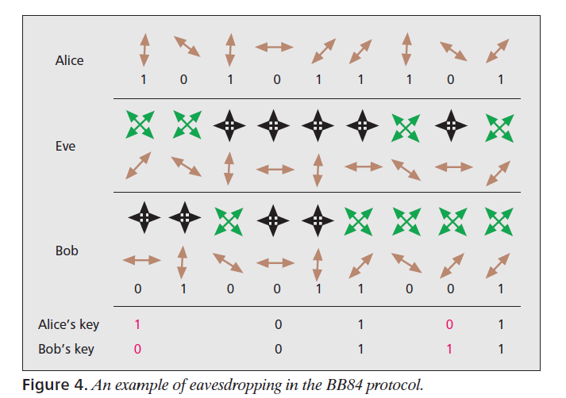

As a result, passive eavesdropping is not possible: when Eve wants to eavesdrop on photons, she will change the quantum states of the photons. Besides, Eve is not able to clone an unknown state of the photon. Therefore, the BB84 protocol ensures a high level of security.

BB84 Protocol Implementation

BB84 protocol coding scheme uses four non- orthogonal polarization states (0º, 90º, 45º and 135º). In this protocol Alice (sender) and Bob (receiver) have to communicate in two types of channel, Quantum Channel (eg. fiber optic or free space) and Public Channel (eg. Internet)
The quantum key distribution using BB84 protocol happens in two stages :
1) Via Quantum Channel (one way communication)
Step 1: Alice sends a sequence of photons to Bob. Each photon is in a state with polarization corresponding to 1 or 0, but with randomly chosen basis.
Step 2: Bob measures the state of the photons he receives, with each state measured with respect to randomly chosen basis either to use diagonal or rectilinear basis.

2) Via Public Channel (two way communication)
Step 1: Bob will use public channel to tell Alice the secret basis (randomly chosen) he choose for every qubits he received during measurement.
Step 2: Alice will compare the list of polarization states which she got from Bob with the one she generated while sending.
Step 3: Alice indicates to Bob what measurements will be correct. This becomes the key.

FLOWCHART

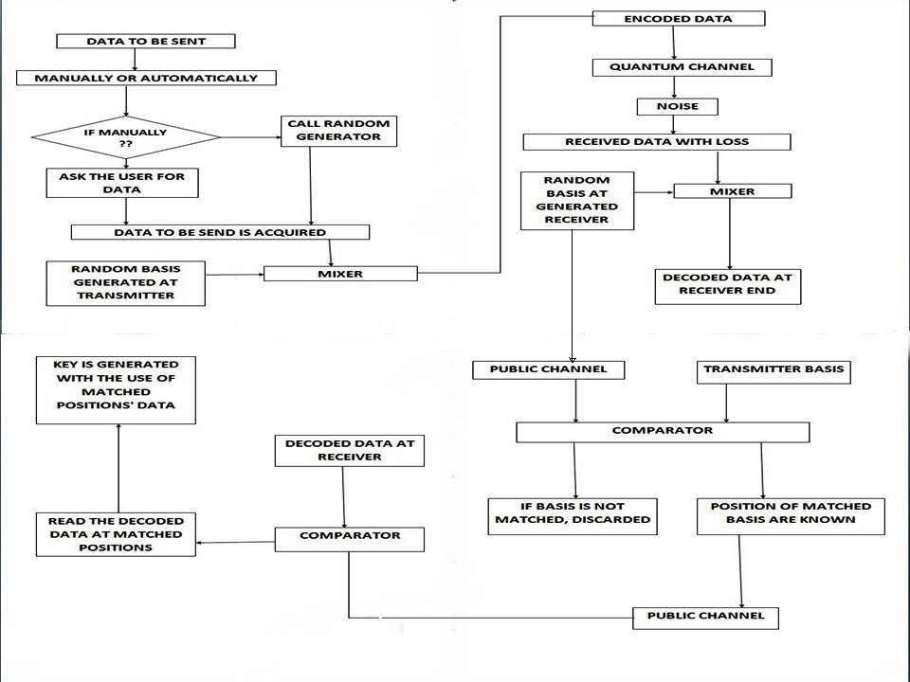

Implementation of BB84 Protocol

For the implementation of BB84, the simulation environment has been developed using C Programming language. This simulation works well for Alice and Bob communicating to each other with or without Eve attacks.
Based on physical implementation of BB84, this simulation is working on two channels, which are quantum channel and public channel. Alice (sender), Bob (receiver) and Eve (eavesdropper) will play their own roles in this implementation. The simulation consists of five objects: Alice, Bob, Eve, Quantum Channel and public Channel. Alice, Bob and Eve will run on separated machine. In Quantum Channel, if there is an eavesdropper taping the communication, the bit will be changed. While the public channel is used by Alice and Bob to communicate for error detection of bit and accordingly, the key is generated. During this phase, Eve can only observe but cannot make any modification on bits.

Proposed Algorithm

The complete algorithm for simulating BB84 protocol in given in the above three blocks: Transmitter Section, Receiver Section and Public Channel Discussion Section. Our model consists of transmitter (traditionally referred to as Alice) and the receiver (Bob) are connected by a quantum communication channel which allows quantum states to be transmitted.

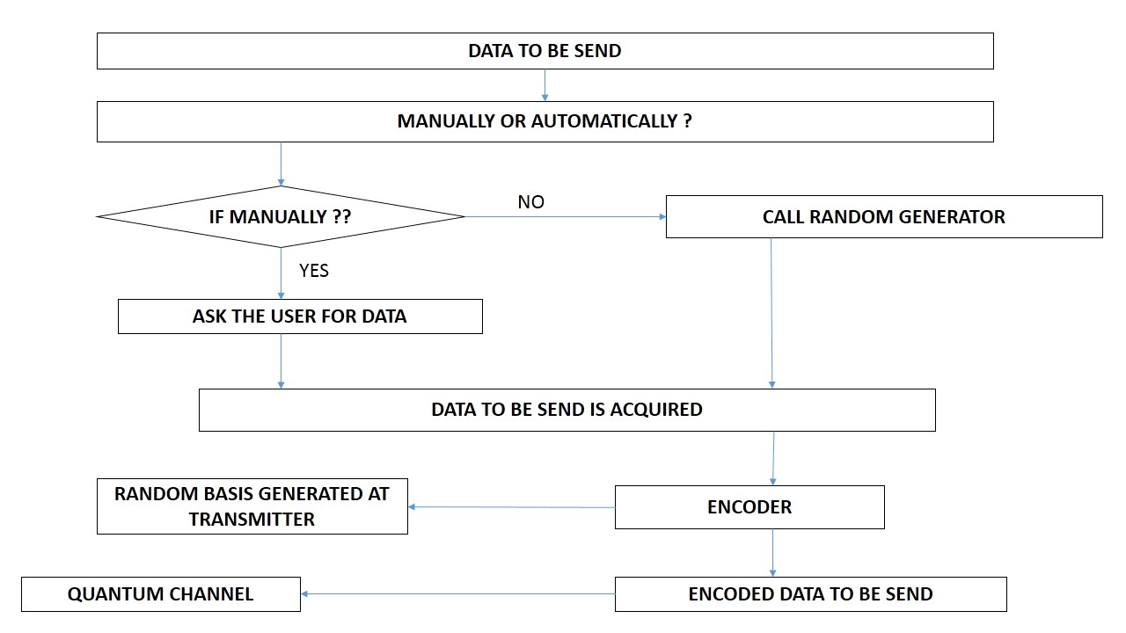
TRANSMITTER SECTION

RECEIVER SECTION
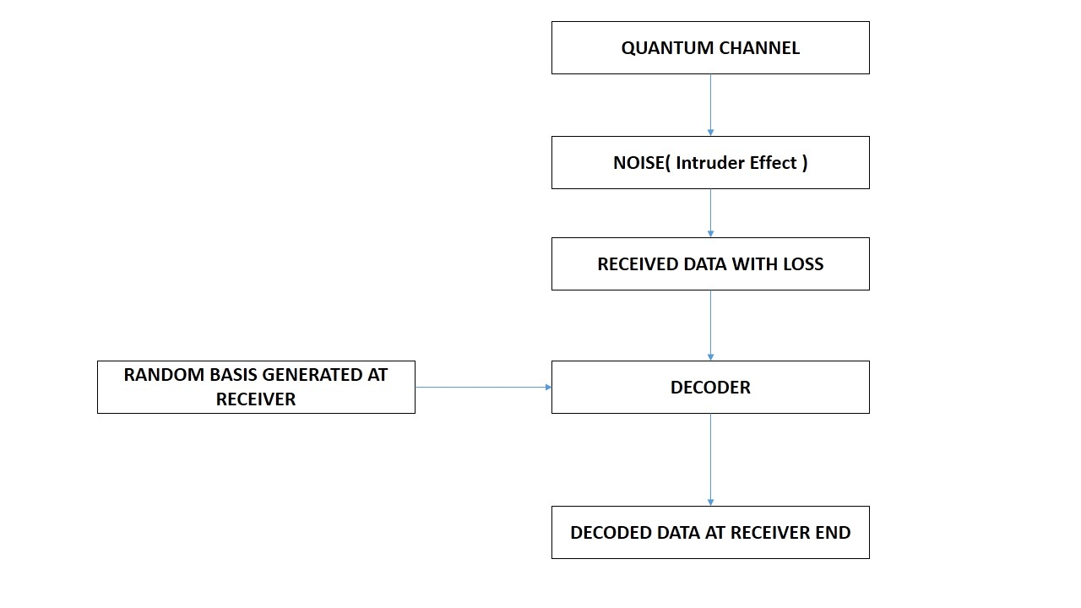

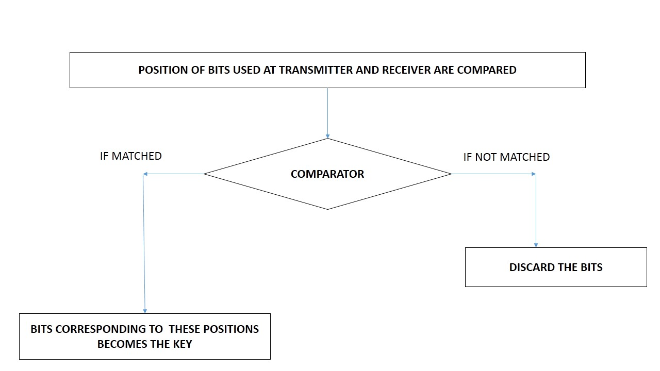
PUBLIC CHANNEL DISCUSSION

The steps of simulation are as follows:
1. First Alice decides the number of bits he wants to send to the Bob.
2. Then he encodes those bits in the form of photons S = {s1, s2, s3... sn} by randomly selecting the basis she wants to use for each bit independently. Those polarized photons are sent through the quantum channel.
3. For each photon, Bob randomly chooses either of the two bases {＋, ×} to decode the photons.
4. Alice and Bob discard all bits corresponding to that position where they use different bases while encoding/decoding.
5. Alice and Bob compute the error rate to decide whether there was an intruder effect present or not. If error rate is greater than some specified threshold then they will discard the sequence of bits.
The complete encoding and decoding is shown in the table:
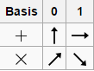

The unique symbols used for the bases used at both ends is shown above:

The Encoding and Decoding (Key Generation) is shown as given below:

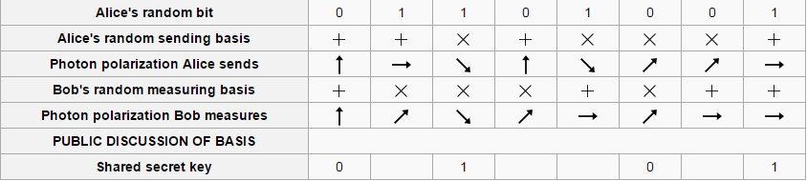

C IMPLEMENTATION

OUTPUT SCREEN SHOTS

Here we can explain the principle of simulation and give the results. In this paper, we perform the simulation based on the BB84 protocol.
During simulation, a particular threshold for data loss (for this simulation, the threshold level is set to 50 %) was chosen to decide the presence of intruder and in such a case, the whole sequence of bits are discarded and retransmission is requested.

- Here, the probability of data loss was found to be 80% which is more than 50% and hence, sender is asked to resend the data.
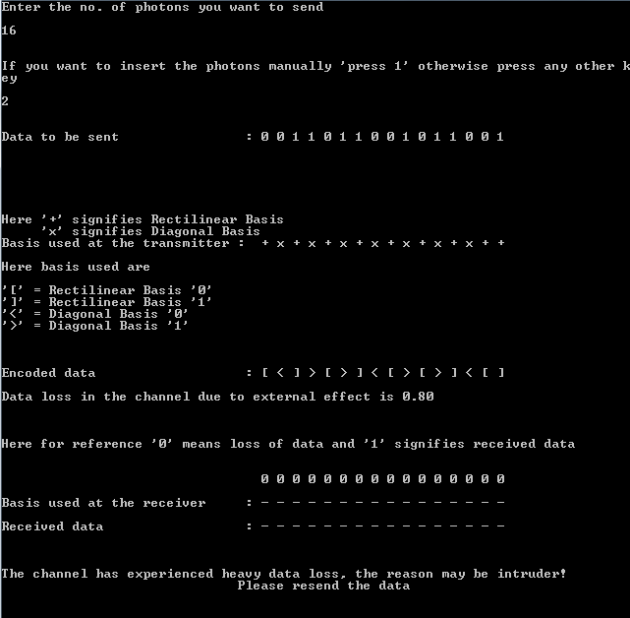
2. Here, the probability of data loss was found to be 10% which is acceptable and hence, the secret key is generated and shown.

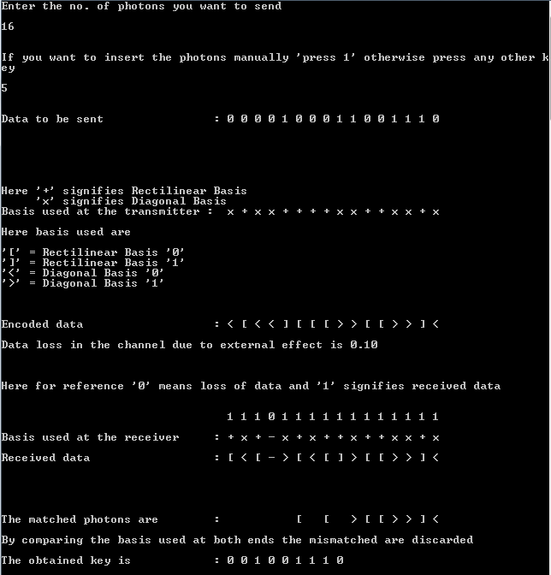

Here, the output of the simulation results are shown in details:

1.

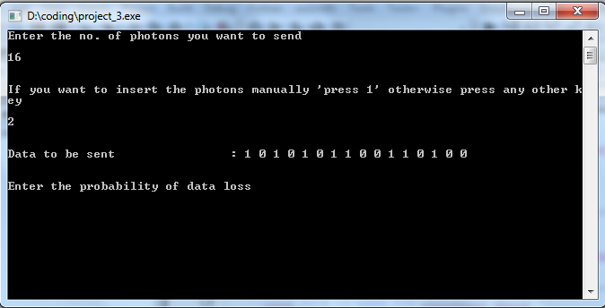

2.

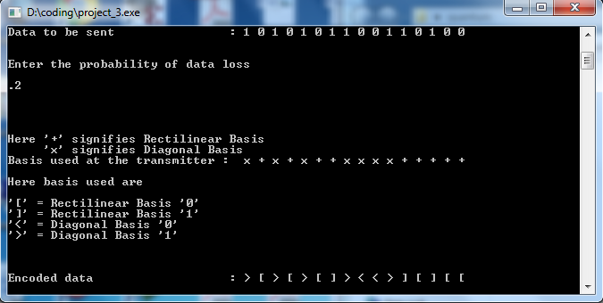

3.

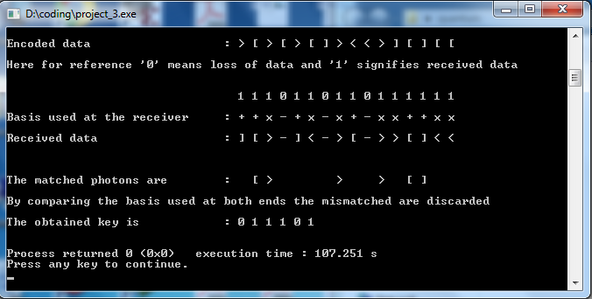
Conclusion

Interest in quantum-based security is growing rapidly at the moment. New implementations of quantum cryptography and new network services supported by this solution are being observed. One example is QKD implementation during the FIFA World Cup competition in Durban, or federal elections in Switzerland where the QC service protected voting ballots against hacking and accidental data modification. The next step will be the integration of QC with network services. Then end users will need
new high-level methods to exchange data securely. When end users wish to control the security of QC, they can modify the low-level parameters of a
QKD system. Unfortunately, it is not easy for ordinary customers to optimize the number of such parameters (error rate level, number and distribution
of compared bits, key reconciliation method, number of rejected bits during privacy amplification, and many others). Therefore, a new high-level security mechanism is proposed. This solution ensures the interaction between the end user’s requirements and lower levels of a given QC system.

REFERENCES

[1] Ergűn GűműŞ, G.Zeynep Aydin and M.Ali Aydin, “Quantum Cryptography and Comparison of Quantum Key Distribution Protocol”, Journal of Electrical & electronics Engineering, vol.8, no.1, 2008.
[2] C. H. Bennett and G. Brassard, ”Quantum cryptography: Public key distribution and coin tossing,” Proceedings of IEEE International Conference on Computers, Systems and Signal Processing, Bangalore (New York, IEEE, 1984).
[3] D.Mayer, J.Assoc. Comput . Mach. 48,351 (2001). Its preliminary version appeared in “Advances in Aryptology-Proc. Crypto” 96, Vol.1109 of Lecture Notes in Computer Science, Ed. N. Koblitz, Springer-verlag, New York, 1996, p.343
[4] P.W.Shor and J.Preskill, [J] Phys Rev.Lett.85, 441(2000)
[5] Vladimir L. Kurochkin and Igor G. Neizvestny, “Quantum Cryptography”, 10th International Conference And Seminar Edm'2009, Section Iii, July 1-6, Erlagol.
[6] Hui Qiao, Xiao-yu Chen, “Simulation of BB84 Quantum Key Distribution in depolarizing channel”, Proceedings of 14th Youth Conference on Communication.
[7] Implementation of BB84 Protocol on 802.11i, Found in Network Applications, Protocols and Services, International Conference on By Nur Hanani Kamarul Aizan, Zuriati Ahmad Zukarnain, Hishamuddin Zainuddin,2010-09,”
[8] Quantum Cryptography,"Vladimir L. Kurochkin, Igor G. Neizvestny",Institute ofSemiconductor Physics, Siberian Division, RAS, Novosibirsk, Russia
[9] P. A. M. Dirac, The Principles of Quantum Mechanics, 4th ed.Oxford, U.K.: Oxford Univ. Press, 1958; reprinted 1978.
[10] Lo, H.-K. Quantum Cryptology. World Scientific, 1998.

